Cold Therapy and Ice Bandages for Your Horse
Drs. Foster & Smith Educational Staff
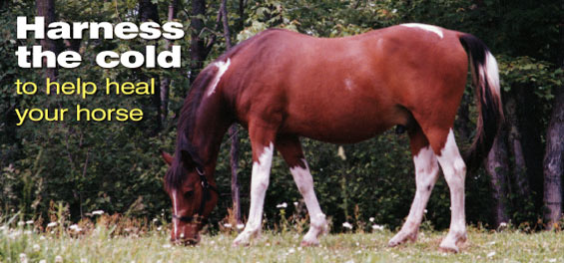
Unfortunately, leg injuries happen to the best of horses, often at the most inopportune times. Hard working field horses can turn a leg in the field. Show horses can stumble under the excitement of the competition lights. Pleasure horses can trip on the riding trail. Either way, the use of cold therapy may help any horse owner ensure their horse is quickly on the road to recovery.
What is cold therapy?
The use of ice on an injured or inflamed leg is known as cold therapy. Proper use can help improve a range of muscle, joint, and soft tissue injuries. The cold temperature of ice helps to decrease blood flow to the injured area. In turn, reduced blood flow helps minimize swelling and inflammation, dissipate heat, and alleviate pain. At the same time, cold therapy slows metabolism of the tissue surrounding the injury, which helps minimize further damage and, as a result, speed healing.
Cold therapy is most effective during the first 48 hours of an injury or inflammation. But the use of ice after a hard workout may also help a horse with chronic conditions, such as weak tendons and ligaments from a past injury. Care needs to be taken, however, whenever cold therapy is used on an injured limb. Bandages wrapped too tightly can compromise circulation. Similarly, ice applied for too long a duration can damage your horse's skin and underlying tissue. The general rule is to ice for 5 minutes and rest for 15 minutes. Repeat this until heat and swelling are reduced. The entire process should be repeated three to four times a day unless otherwise directed by your veterinarian.
If your horse has a leg injury, contact your veterinarian if:
- The lameness is severe
- Your horse is reluctant to move
- There is an open wound
- The injured area is warm to the touch
- Your horse has a fever
- Your horse has lost his appetite
- There is excessive swelling
- Your horse seems to be in moderate to severe pain
How to use cold therapy
There are a range of ice packs and flexible bandages available to make cold therapy easy. The best products to choose will depend, in part, on where your horse's leg injury is located. A more rigid ice pack with standard leg wraps or bandages will better suit some locations of your horse's leg. Other areas, such as along the fetlock or cannon, will be better treated with the use of flexible Ice Cells and traditional wraps or bandages. To target even more specific regions of your horse's lower leg, special cooling bandages, such as the Equi-N-Ice Bandage, combine flexible cotton bandages with cooling menthol-based solutions.
Cold therapy tips
Some horses are very responsive to cold temperatures. Even if your horse is not, his attitude could change when you are trying to apply an ice pack to an inflamed leg. To help minimize the cold temperatures:
- Use a damp cloth as a buffer between the ice pack and your horse's skin
- Do not place ice packs directly onto open wounds. First use several layers of cotton gauze
- If possible use Vetrap, CoFlex, or PowerFlex bandages on the area between cold therapy treatments to help reduce swelling

